**Battle of Neighborhoods in Medellín**

**Capstone Project, Coursera-IBM Specialization**

Aníbal J Guerra S, [ajguerras@gmail.com](mailto:ajguerras@gmail.com)

Medellín, Colombia

1. Introduction

In this lab, you will learn how to convert addresses into their equivalent latitude and longitude values. Also, you will use the Foursquare API to explore neighborhoods in New York City. You will use the **explore** function to get the most common venue categories in each neighborhood, and then use this feature to group the neighborhoods into clusters. You will use the k-means clustering algorithm to complete this task. Finally, you will use the Folium library to visualize the neighborhoods in New York City and their emerging clusters. Click [HERE](http://cocl.us/DP0701EN_Coursera_Week3_Notebook2) to download the lab notebook (.ipynb)

1. Problem Description

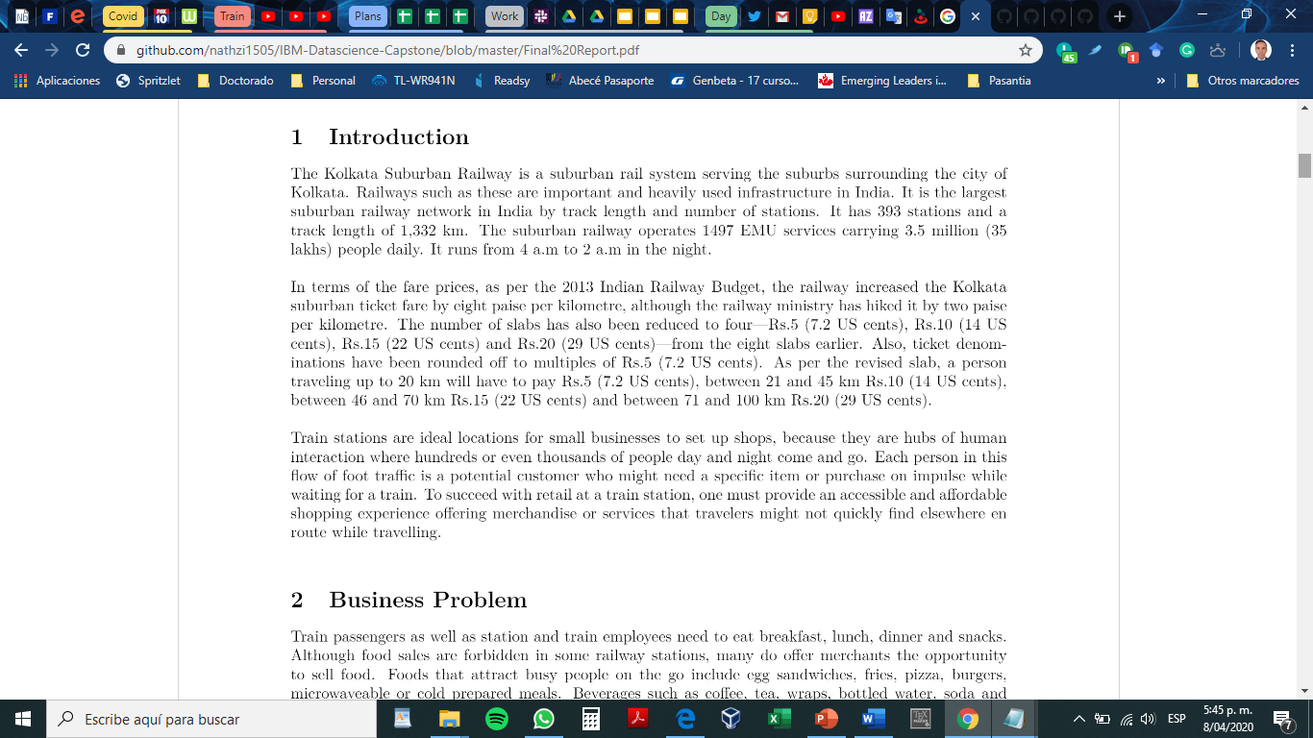

1. Data Description
2. 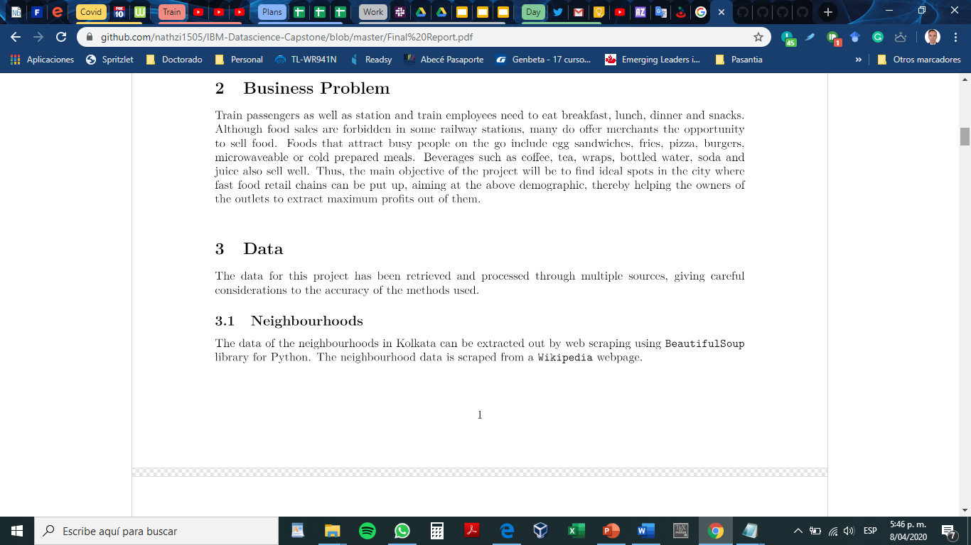
   1. Neighborhoods
   2. Geospatial data
   3. 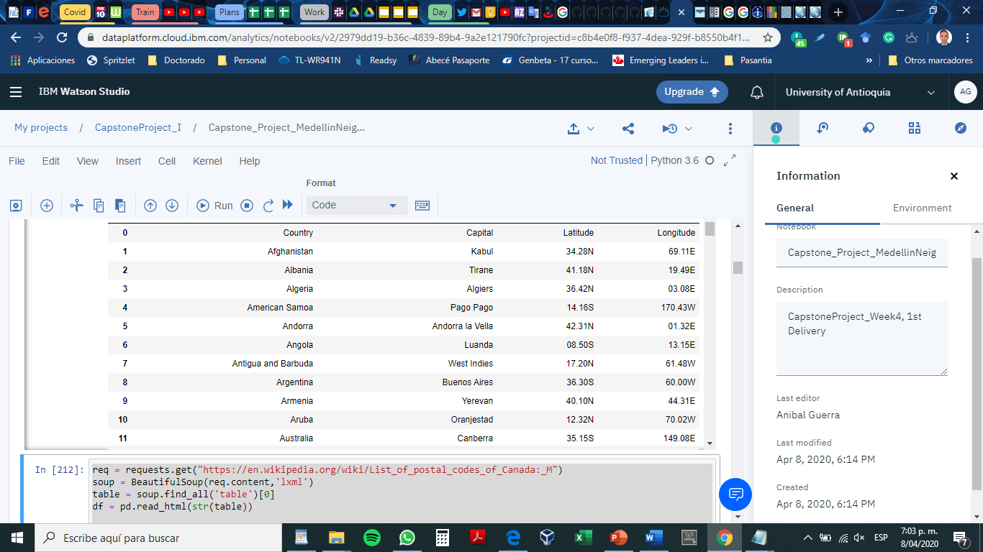
   4. Venues

Describe the data that you will be using to solve the problem or execute your idea. Remember that you will need to use the Foursquare location data to solve the problem or execute your idea. You can absolutely use other datasets in combination with the Foursquare location data. So make sure that you provide adequate explanation and discussion, with examples, of the data that you will be using, even if it is only Foursquare location data.

This submission will eventually become your **Data** section in your final report. So I recommend that you push the report (having your **Data** section) to your Github repository and submit a link to it.